AUS Community Services

User guide – Volunteer App

**Sign up and sign in**

On launch of the application the user would see a splash screen to welcome him to the application.

After that the user would come across the sign in page, however he would first have to sign up to create an account.

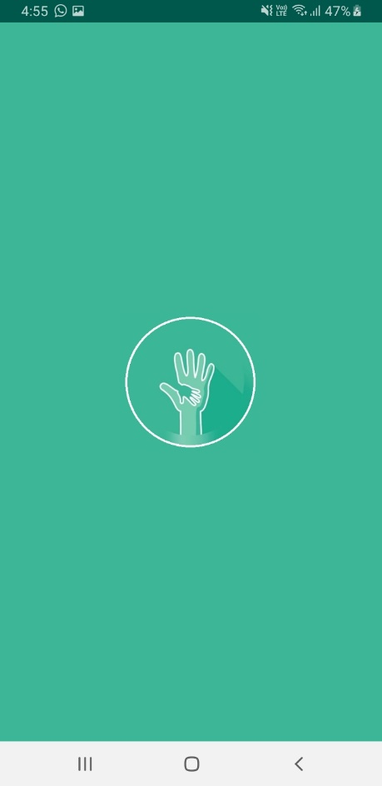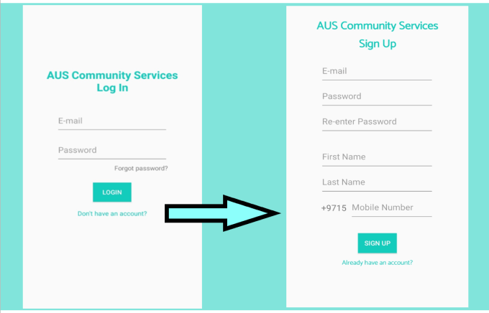

After filling the fields, the user would click sign up and get a toast confirming a successful registration and a request asking him to click on the link sent to his email so he can verify his account.

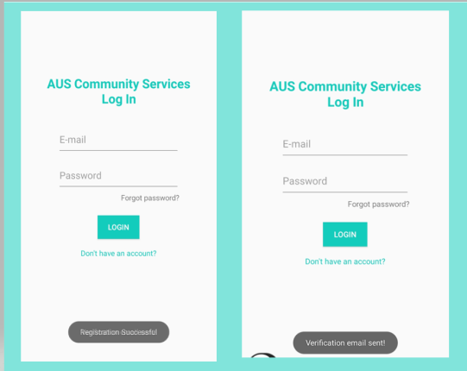

On checking his email, the user would find an email with a link to verify which he can click to lead to the firebase verification which will mark his email as verified.

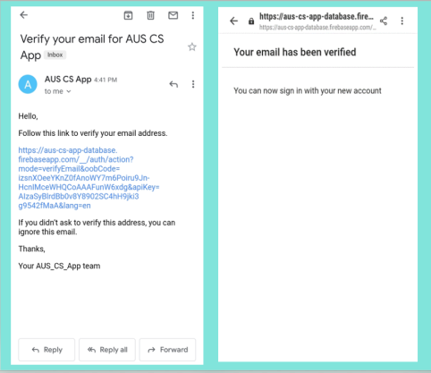

The user can now login with his entered credentials.

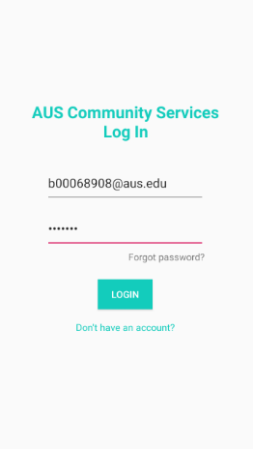

**Registering to an event**

The main screen the user would see on logging in is the event list which contains a list of all upcoming events.

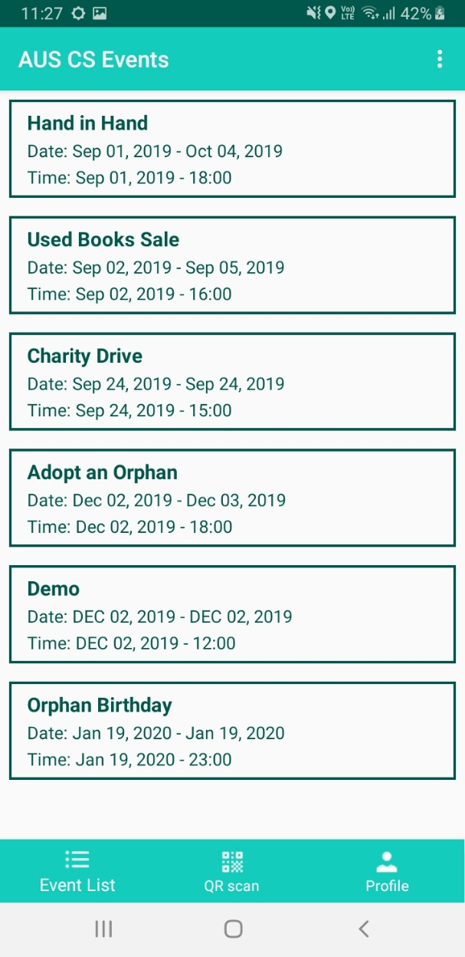

The user can click on any one event to view further details such as the location both in text and a map to the location.

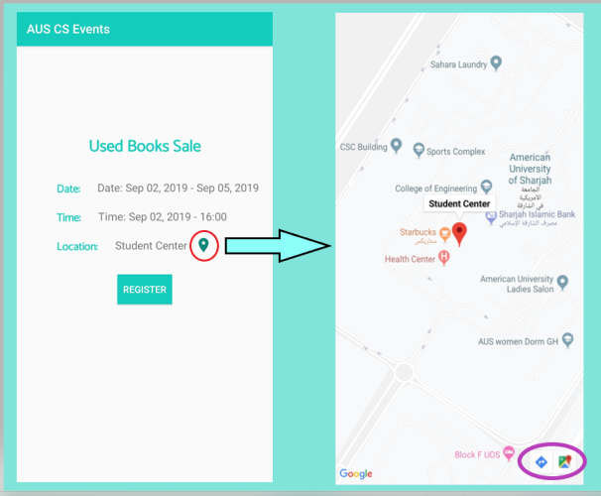

When the user clicks on the location icon, he will be taken to a map screen which displays the exact location of the event. The screen also has the option to open in google maps and the option to open in maps with directions to the location (buttons seen in purple circle).

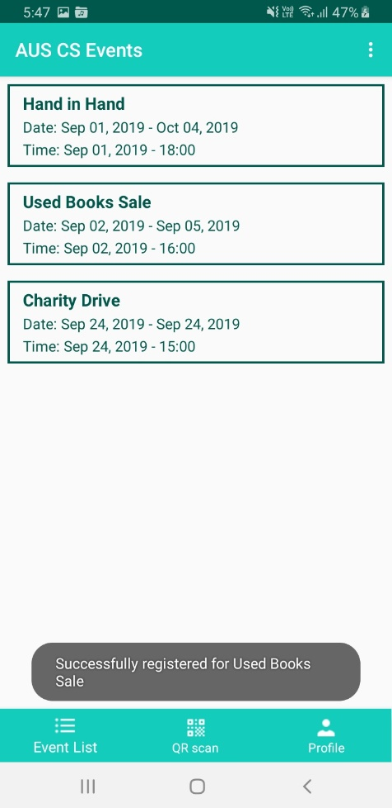Additionally, the user can also click register to express his interest in attending the event and will get a message saying he has successfully been registered and will be taken back to the list of all the events.

**Unregistering from an event**

The user can view a list of all his registered events by clicking on the Registered Events button on the user profile page. This will open a list of all the events the user is registered in.

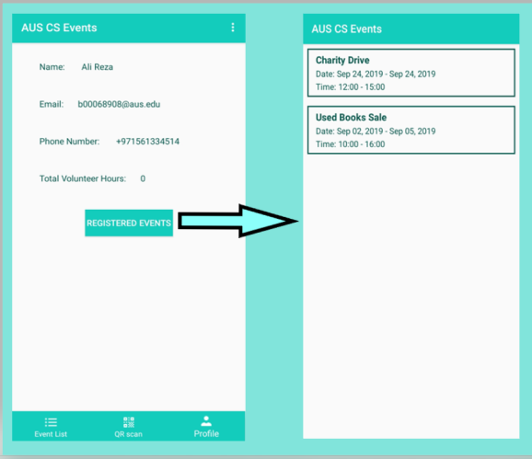

The user can then click an event to see the details again and click the unregister to be unregistered and taken back to the registered events list.

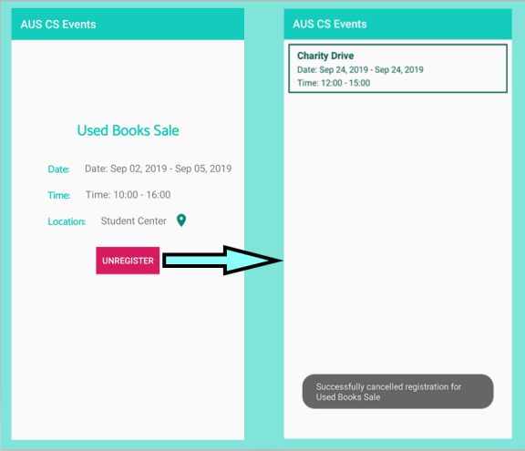

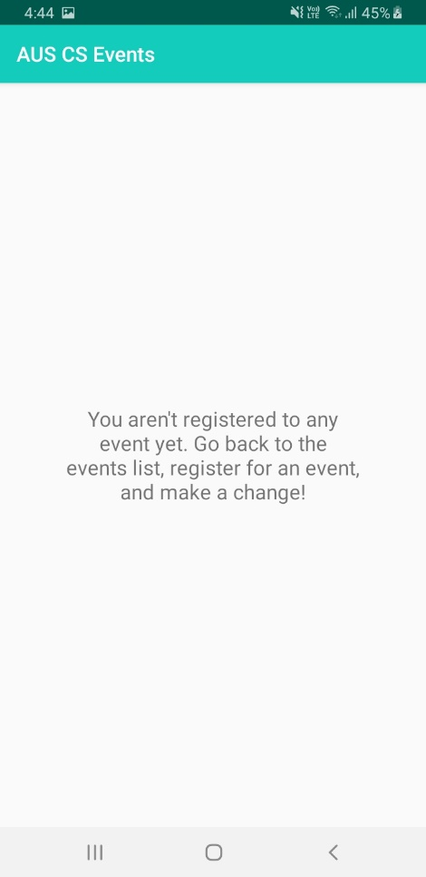In case in the user isn’t registered in any events such a message will be displayed to the user.

**About us**

To know more about the application or to report bugs users can open the About page located in the menu and click on either the phone number or the emails to be taken to the corresponding app with the details pre-entered.

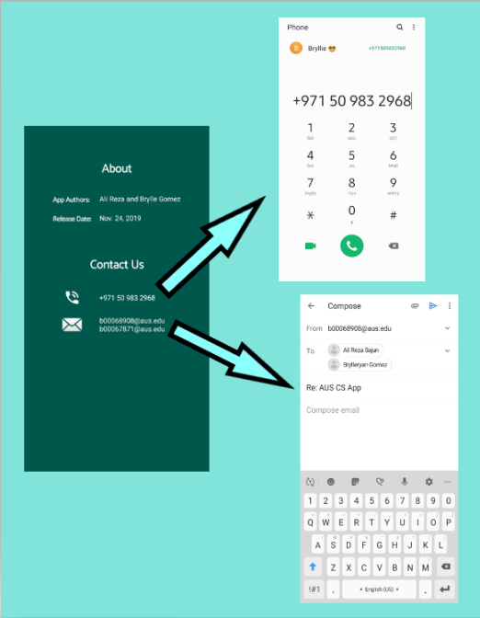

**On new event added**

On adding of a new event, the user will get a notification saying that a new event is added and they can click the notification to open the event list.

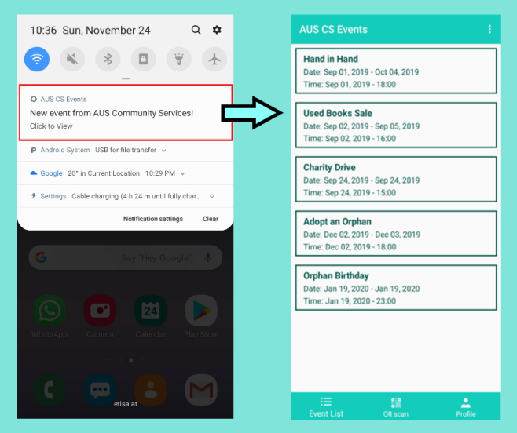

**Registering attendance to an event**

To mark their attendance, the user can simply scan the QR code provided by the admin as shown below.

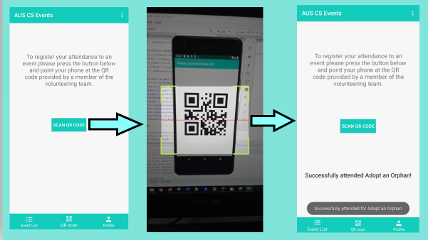

This would then automatically update the user’s volunteering hours in the profile as seen below:

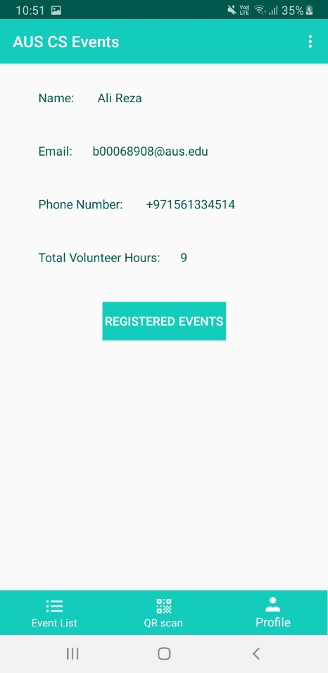

**Logout**

To sign out of the application the user can simply select Sign Out from the menu and will be prompted to confirm before the application goes to the login screen.

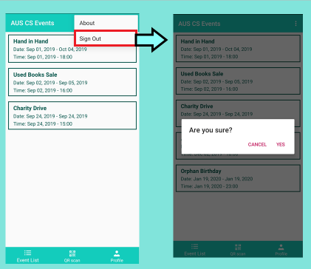

User guide – Admin App

**Sign up and sign in**

On launch of the application the admin would see a splash screen to welcome him to the application.

After that the admin would come across the sign in page, however he would first have to sign up to create an account. To prevent unauthorized access the admin has to add a access code given to him by other admins in order to proceed.

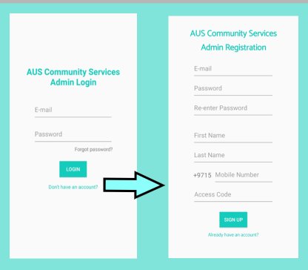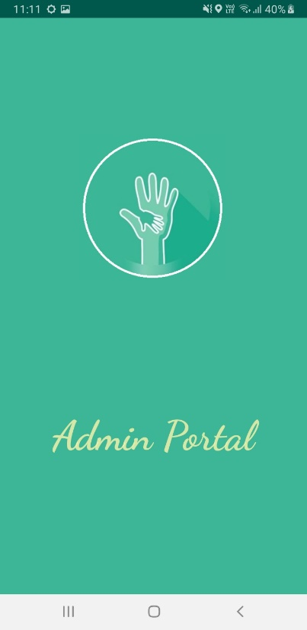

After filling the fields, the user would click sign up and get a toast confirming a successful registration and a request asking him to click on the link sent to his email so he can verify his account.

On checking his email, the user would find an email with a link to verify which he can click to lead to the firebase verification which will mark his email as verified.



The user can now login with his entered credentials.

**Adding an event**

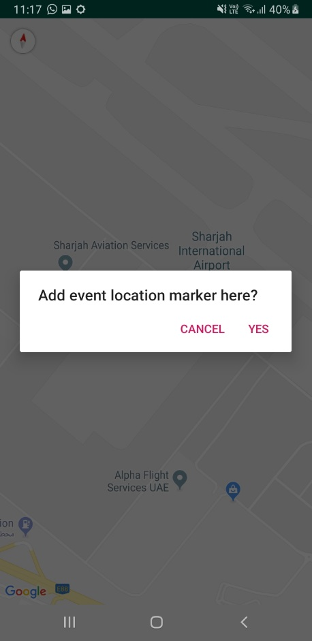The user can go to the Add Event tab to add an event. He would then be led to a screen where he can enter details before being able to choose the location on a map.

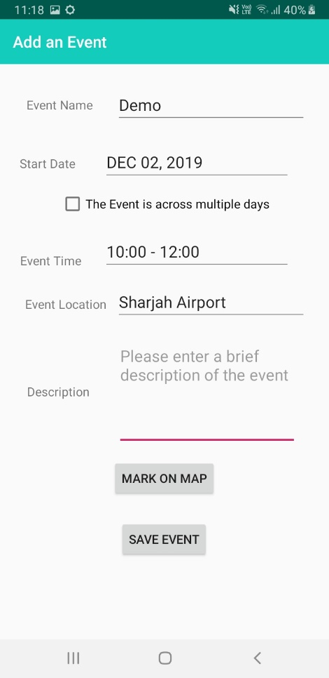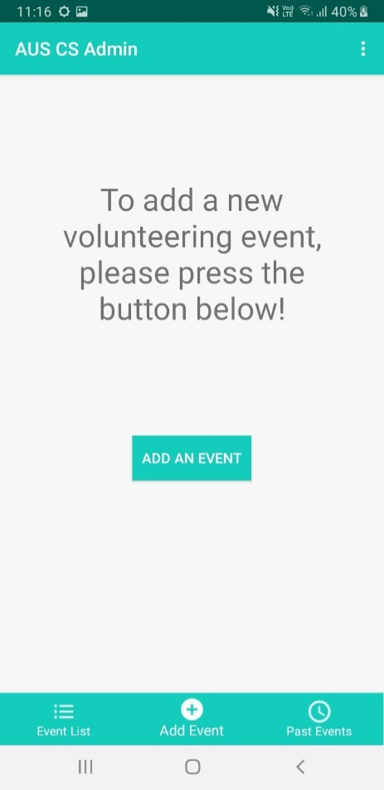

The event can then be seen in the admin’s list of events:

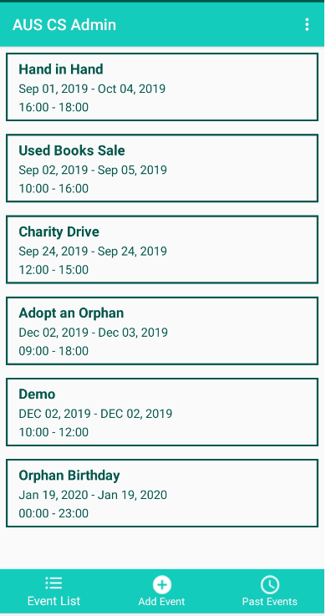

**About us**

To know more about the application or to report bugs users can open the About page located in the menu and click on either the phone number or the emails to be taken to the corresponding app with the details pre-entered.



**Generating QR code**

The admin can go to the event details screen and click a button to generate a QR for that event.

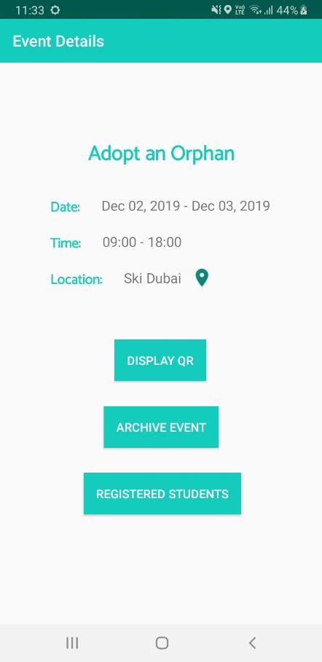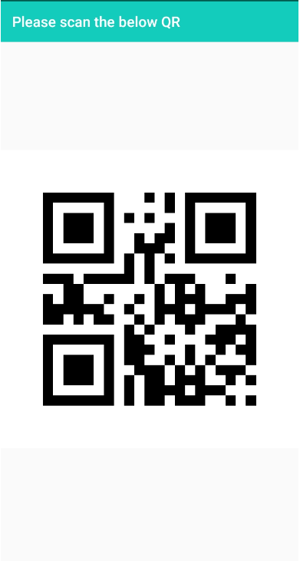

**View registered users**

From the event details page the admin can view a list of users who have expressed their interest in attending the event.

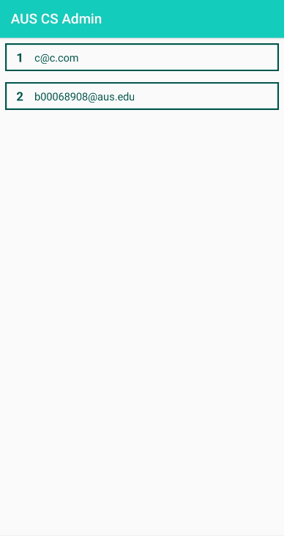

**Generate Access Code**

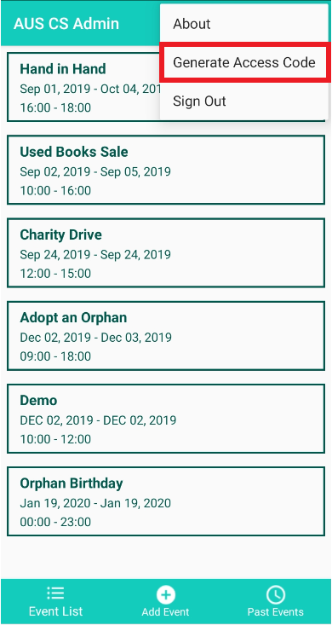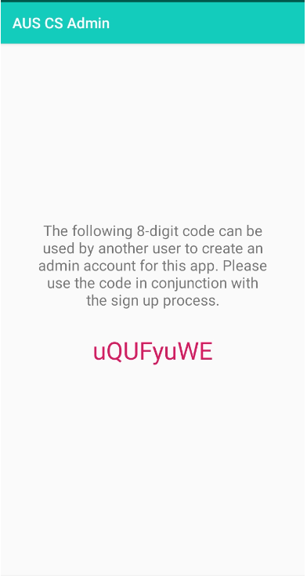For a new admin to login a current admin can generate an access code by going to the generate access code in the menu.

**Archive event**

When an event is done the admin can remove it from the list of upcoming events by archiving it. This will send the event to a list of past events visible only to the admin.

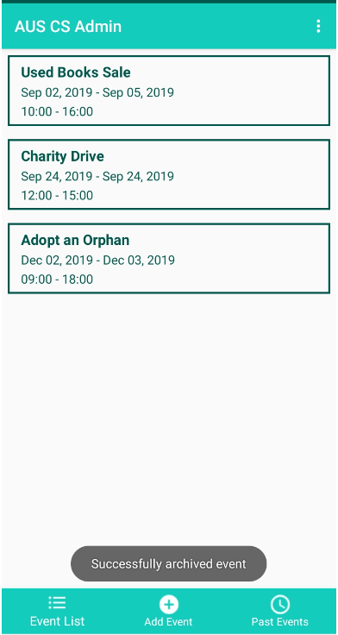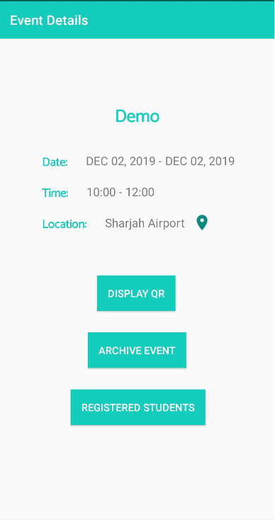

**Logout**

To sign out of the application the user can simply select Sign Out from the menu and will be prompted to confirm before the application goes to the login screen.

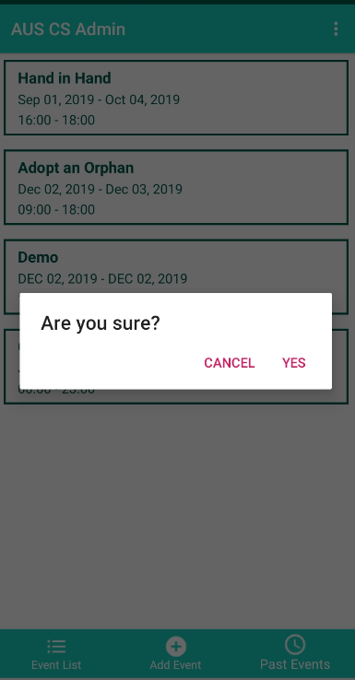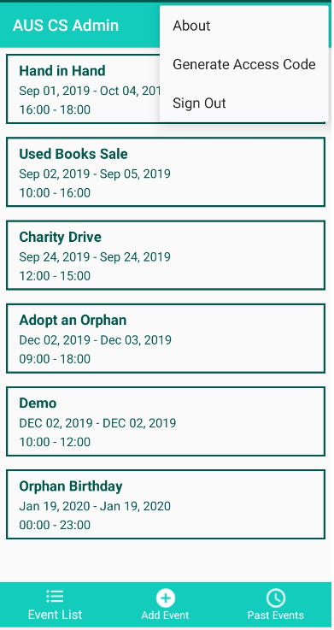

**Past events**

Archived events are displayed in this fragment. The user can click on any of the displayed past events for more details. In a past event’s detail page, the “Volunteer List” button can be clicked to view the list of all the students who attended and volunteered for the activity.

